Write an assembly language program to arrange numbers in Ascending order.

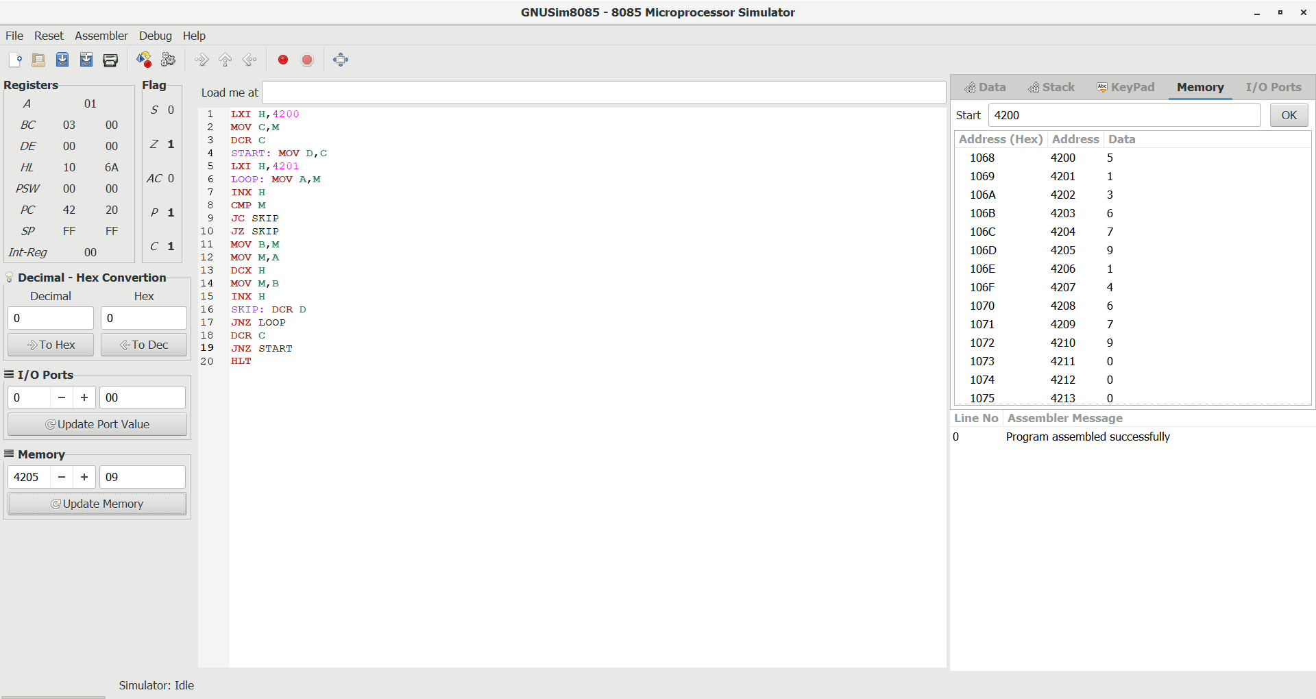

Write an assembly language program to arrange numbers in Descending order.

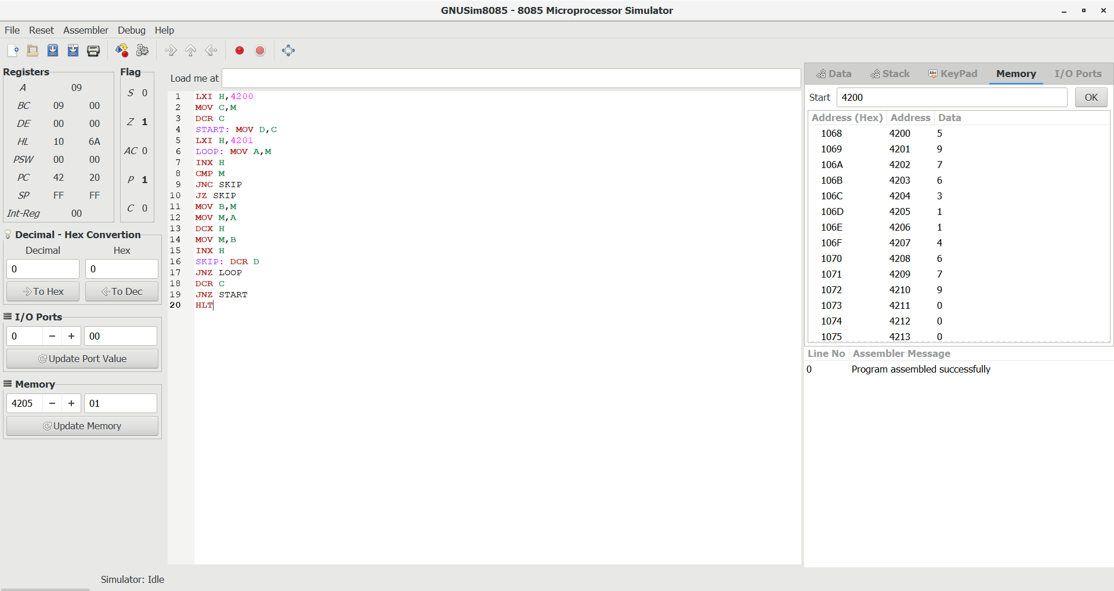

Write an assembly language program to find the largest number in an array.

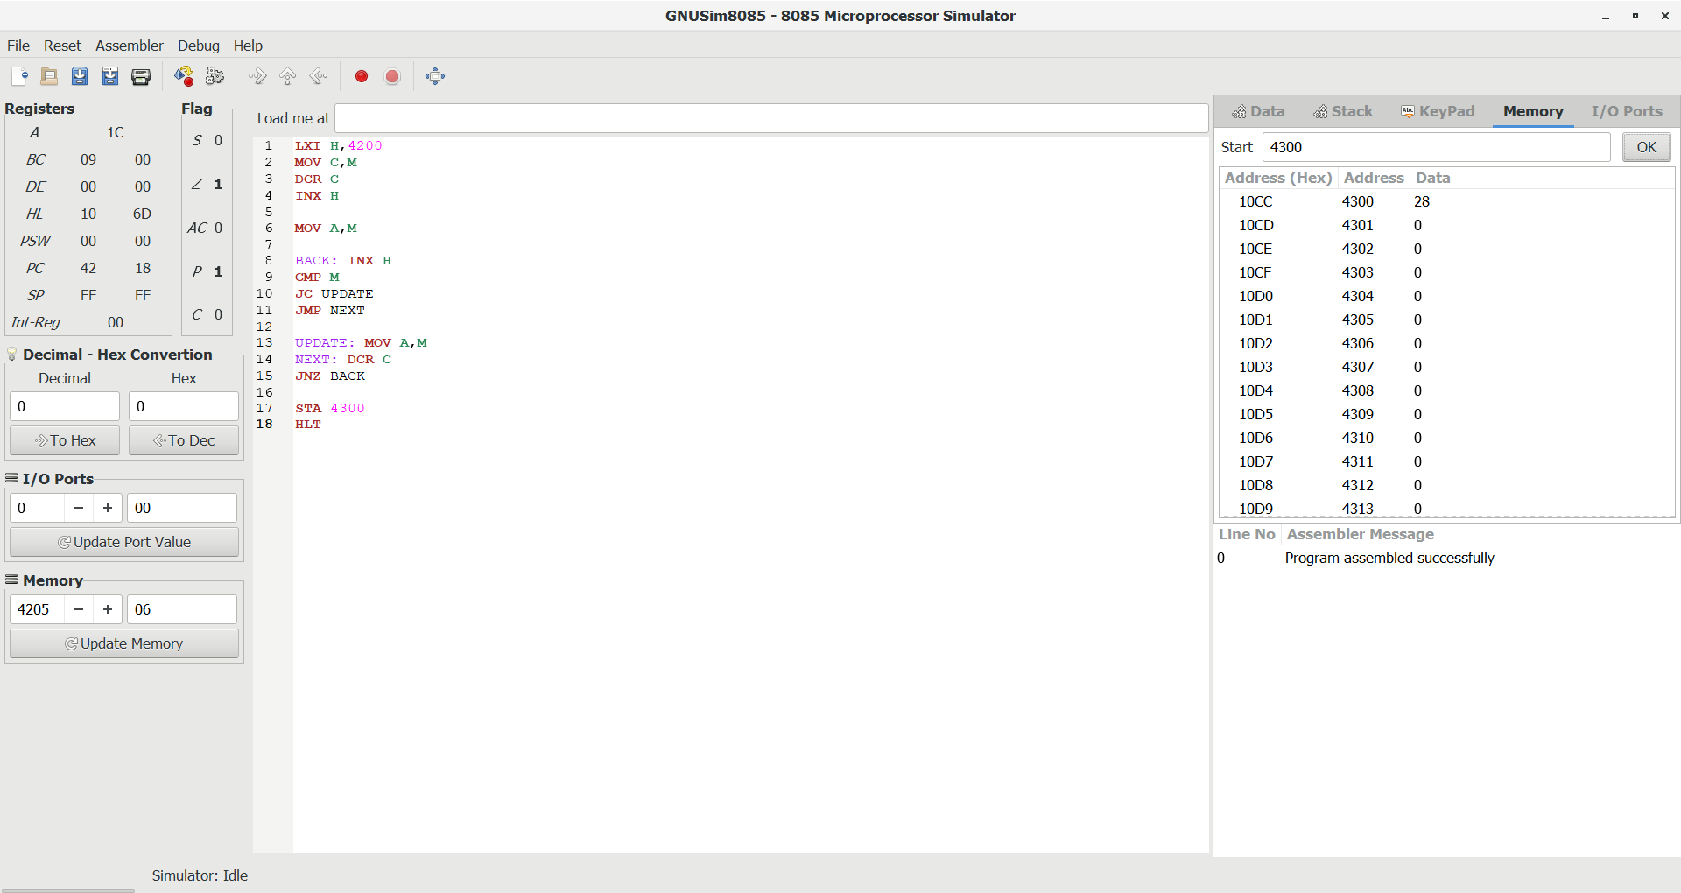

Write an assembly language program to find the Minimum number in an array.

